Mrs. Mallory, Mrs. Angie, Mrs. Kelly, and Mrs. Daphne’s Weekly Buzz
September 28 – October 2, 2020
Dates to Remember
Oct. 6 – Deadline for Flu Shot Papers
Oct. 9 – Picture Day
What we’ve been reading…
During each story throughout the week we have been learning new vocabulary words. We’ve searched for the new words in each book, have discussed their meanings, and used them in sentences.

The Full Belly bowl
New Vocabulary: generous, meager
Lola at the Library
New Vocabulary: borrow, section, choose, librarian

Try using some of these new vocabulary words with your little ones during everyday conversation.

Math Skills
This week we have been sorting letters and numbers and have been practicing using five frames. We have also begun working on recognizing coins (pennies, nickels, dimes, and quarters) and knowing how much each coin is worth.

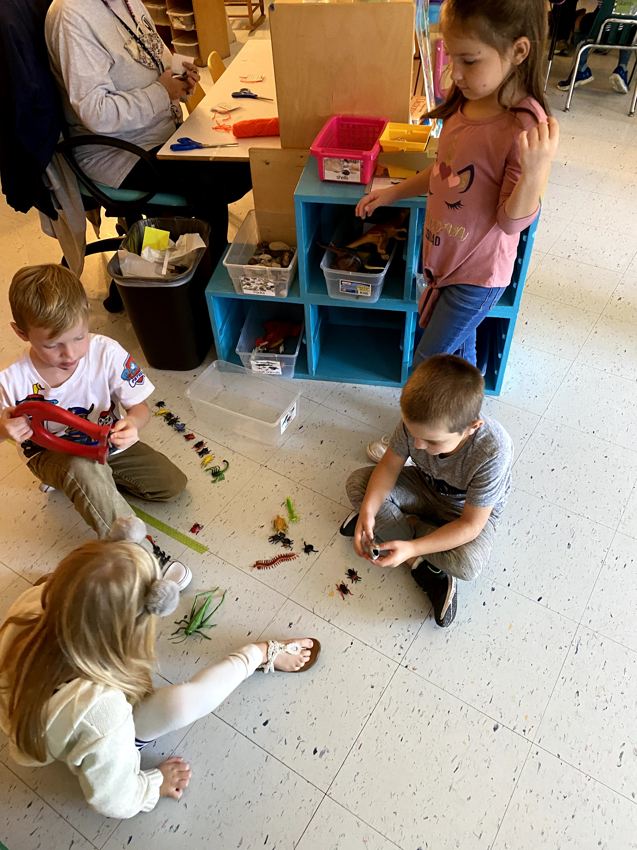

Science Center Fun
